# Simple Solute Transport Model

The purpose of this exercise is to illustrate the process of creating a simple groundwater transport model in ModelMuse. For more information about solute transport modeling, you may wish to consult Zheng, C. and Bennet, G.D. 2002. Applied Contaminant Transport Modeling, second edition, John Wiley & Sons, New York, 621 pp. In addition Volume 49, issue 5 of the journal Ground Water contains a series of papers outlining some of the important developments in solute transport modeling.

Advection, hydrodynamic dispersion (including molecular diffusion) and retardation may all need to be taken into account in solute transport models.

* Advection- The process whereby solutes are transported by the bulk mass of flowing fluid (Freeze and Cherry, 1979). See also convective transport (<http://or.water.usgs.gov/projs_dir/willgw/glossary.html>).
* Hydrodynamic dispersion - The spreading (at the macroscopic level) of the solute front during transport resulting from both mechanical dispersion and molecular diffusion (Bear, 1979) (<http://or.water.usgs.gov/projs_dir/willgw/glossary.html>).
* Retardation is the slowing of the movement of a solute relative the movement of water ascribed to sorption or other reactions between the solute and the porous medium.

If you attended the earlier workshop, this exercise may look familiar because the flow model portion is a modified version of the one you created in that workshop. There are a number of important differences, however. 1. The length and width have all been reduced by a factor of ten. 2. The elevation contrast has been increased. 3. The mainstream is modeled as a drain instead of a combination of a river and a drain.

Solute transport modeling is often done with MT3DMS (<http://hydro.geo.ua.edu/mt3d/>). MT3DMS does not model fluid flow; it only models the solute transport. It uses the fluid flow results from MODFLOW as part of its input. Thus the first step in creating a solute transport model is to create a fluid flow model. We will not create the flow model here. Instead, we will use one that has already been created and modify it to add solute transport.

# Flow model

We will start off by exploring the flow model. If you wish, you can skip this section and go directly to step 7.

1. Start ModelMuse and open Watershed.gpt.
2. Select "View|Show or Hide 2D Grid|Show active edge. You model should now look similar to this. The outline on the top view of the model is the edge of the active part of the model. Cells outside that line are inactive.

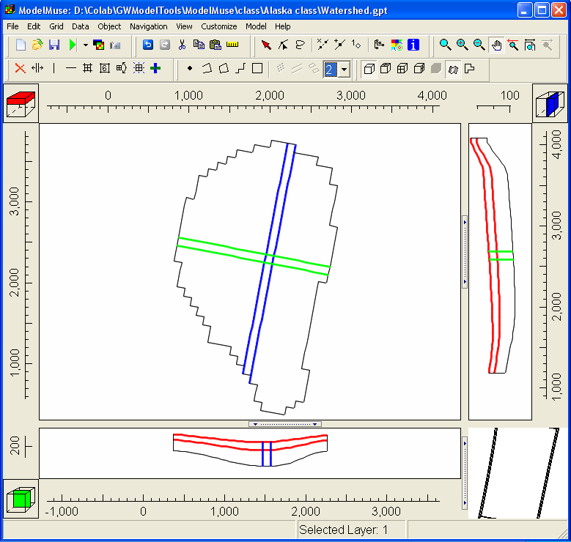

1. Select "Model|MODFLOW Packages and Programs". Then expand "Boundary condtions|Specified flux" and "Boundary condtions|Head-dependent flux". Note that the Recharge and Drain packages are selected. Click Cancel to close the dialog box.
2. Select "Object|Show or Hide Objects..." Then expand MODFLOW Features and check the check box for the Drain package to see where the drain is located. If you wish, you can do the same with the Recharge package or any of the other choices. When you are done, uncheck "All Objects" to hide all the objects. If you wish, you can close this dialog box.
3. Select "Data|Data Visualization". On the left select "Color Grid". Then select DRN Elevation from the combobox as shown on the left hand illustration below. Click Apply. The top view of the model should look something like the right hand illustration below.

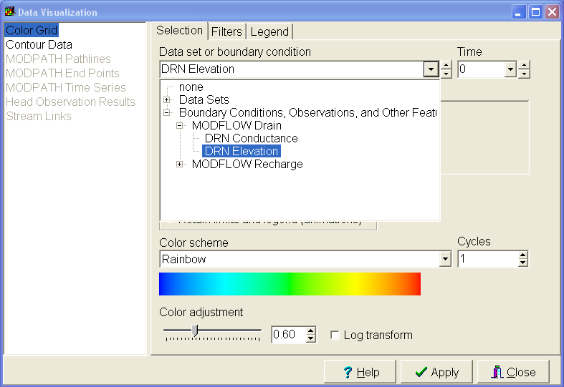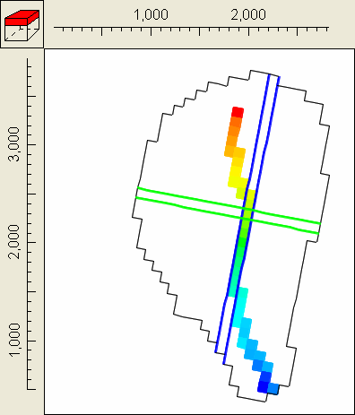

1. Select "Data|Show Grid Values". Then move the cursor over the top view of the model while watching what is displayed in the Grid Value dialog box. Notice that when the cursor is over a drain cell, the drain elevation is displayed along with an explanation of how that value was assigned.

# Creating the Solute Transport model

Next we will create a transport model starting with this flow model.

1. Select "Model|MODFLOW Packages and Programs". Then expand MT3DMS and check the check box for the "BTN Basic Transport package". (The check box for "GCG Generalized Conjugate Gradient Solver" will be checked automatically.) Type "tracer" as the name of a "Mobile Species". Also check the check boxes for the "ADV Advection package" and the "SSM Sink and Source Mixing package". Then click OK. When you click OK, you will get a message telling you that you will have to run MODFLOW again before you can run MT3DMS. Click OK to dismiss the message.

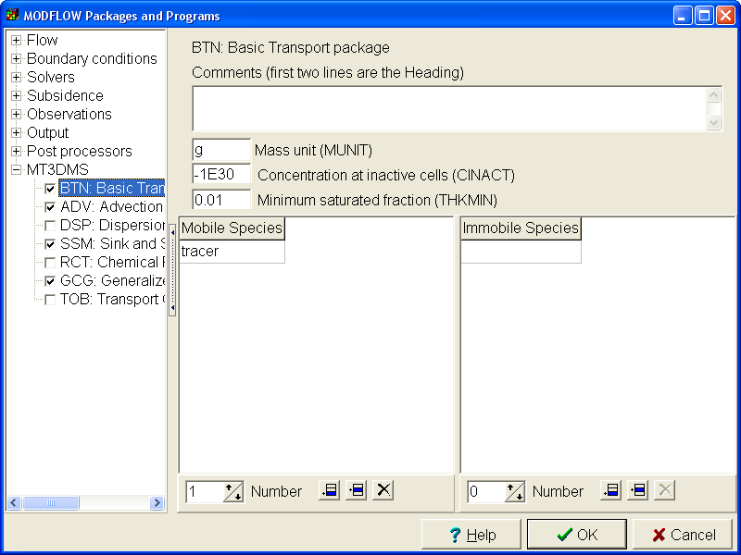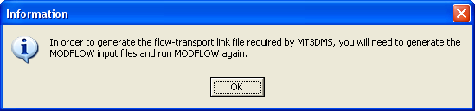

1. When you activated, MT3DMS, several new data sets were created for data required by MT3DMS. Select "Data|Edit Data Sets" to see those new data sets. To see the data set for which this data is required, switch to the "Comment" tab and read the name of the data set in the "Associated model data". You don't need to change any of these data sets, so click Cancel to close the dialog box.

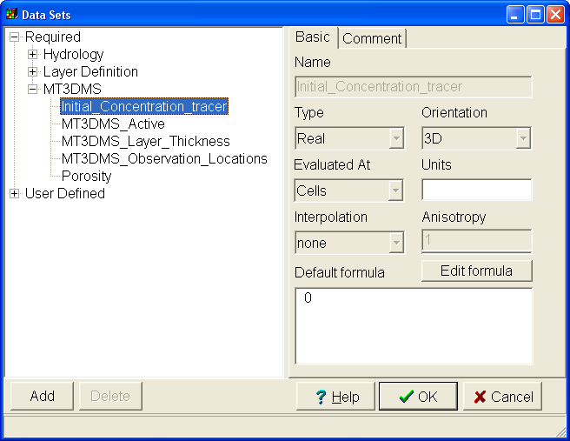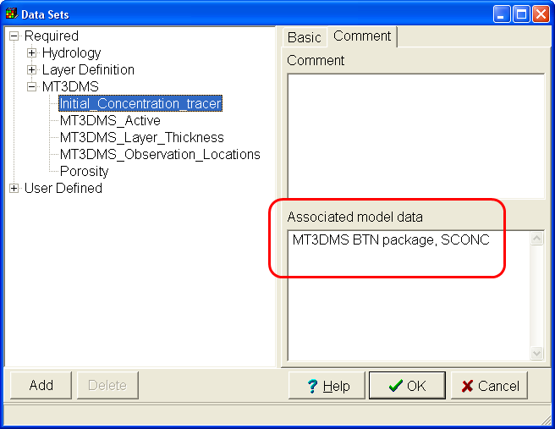

1. We will set the initial concentration to a higher value in one cell. Select "Object|Create|Point| and then click on Column 4, Row 12. (The column and row numbers are displayed on the status bar.)
2. The Object Properties dialog box will open. Set the "Number of Z formulas" to One and set the "Z-coordinate" to "Model_Top". Then go to the Data Sets tab and check the check box for "Initial_Concentration_tracer" to 100. Click OK to close the dialog box.

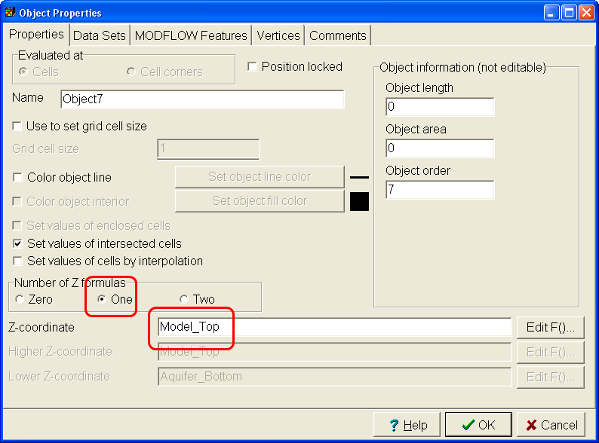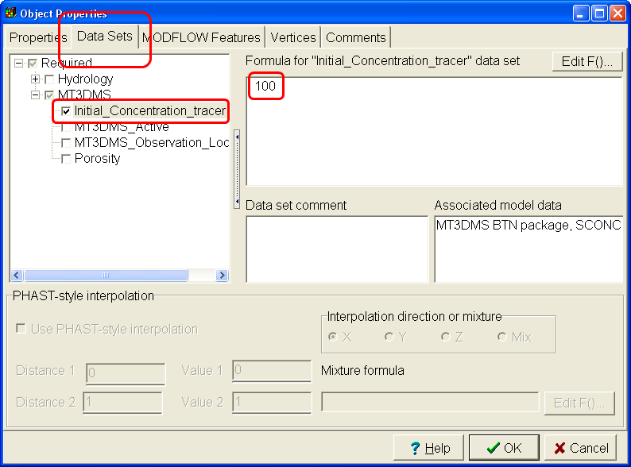

1. We need to tell MT3DMS, the concentration of the tracer in the recharge. To do that we will open the object that defines the recharge in the Object Properties dialog box and enter the concentration there. Select "Object|Show or Hide Objects", expand "MODFLOW/MT3DMS Features" and then expand "RCH: Recharge package". Double-click on "Recharge_Object" to open the object in the Object Properties dialog box. (This is one of several ways to open an object in the Object Properties dialog box. Go to the MODFLOW Features tab and check the check box for the "SSM: Sink and Source Mixing package". Change the "Number of times" to 1, and select 0 as the Starting time. The ending time will be automatically be set to 3155760000. (This number is the number of seconds in the first stress period and is equivalent to 100 years.) Set the concentration to zero. Click OK to close the dialog box.

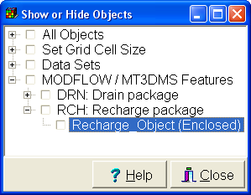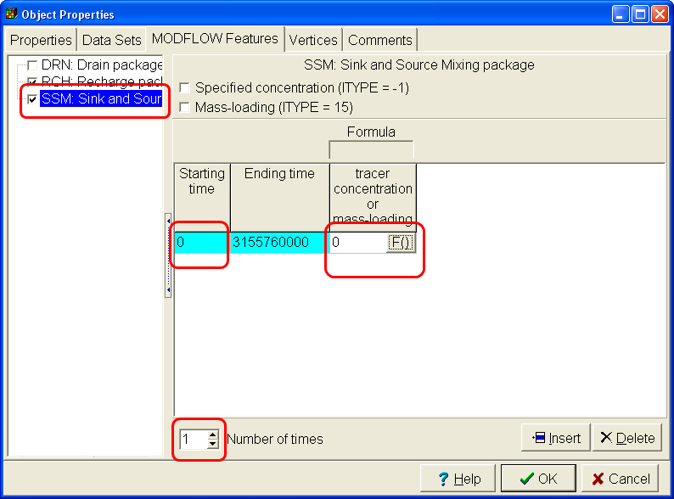

1. Select Model|MODFLOW Time. Switch to the MT3DMS tab. If desired, you could have the times for the MT3DMS model be different from those of the MODFLOW model (although it couldn't start at an earlier time than the MODFOW model or end after the last time in the MODFLOW model). We won't make any changes here so just click Cancel to close the dialog box.
2. To reduce the amount of data that will be saved to file, we only will save the data for every 109. seconds To do this, select "Model|MODFLOW Output Control". Select MT3DMS on the left and then change NPRS to "at specified times”. Change the number of output times to 3 and enter the following times in the table. 1000000000, 2000000000, 3000000000

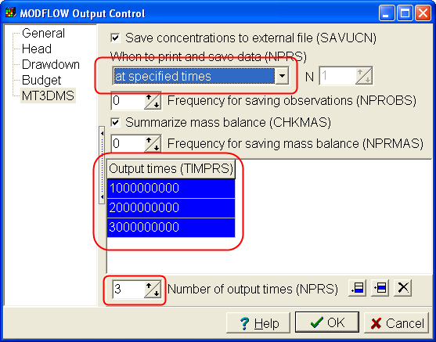

1. The next step is to run the model. You must first run MODFLOW and then run MT3DMS. Select “File|Export|MODFLOW Input Files” or click the “Run MODFLOW” button and then click the Save button. Once MODFLOW has finished running, select “File|Export|MT3DMS Input Files” or click the down arrow next to the “Run MODFLOW” and select “Export MT3DMS Input Files” and then click the Save button to run MT3DMS.

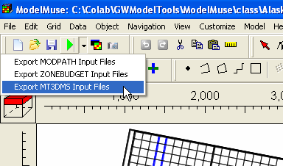

1. To see the model results, select “File|Import|Model Results” or click the “Import and display model results” button . Then select the file with the extension “.ucn”. Select all the data sets and click OK.



1. Select Data|Data Visualization, change the selected data set to “Concentration_Tracer_P1_S1_TS49” and click Apply.Then click on the Model Cube on the top view of the model to change the selected layer to layer 2. You should get something similar to the image below. In the data Visualization dialog box, be sure to look at the Legend tab and make note of the highest concentration at this time.

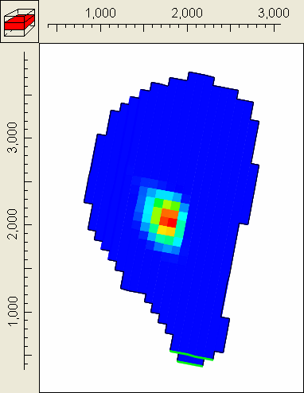

1. Now change the data set in the Data Visualization dialog box to Concentration_Tracer_P1_S1_TS98 and click Apply. You should get something similar to the image below. Be sure to check the legend tab and note how the scale has changed from what it was before.

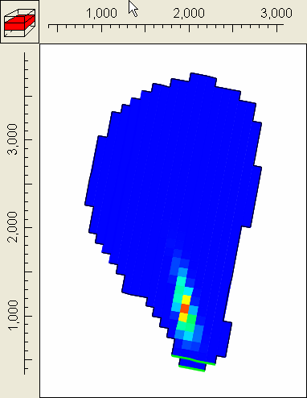

# Dispersion (optional)

1. Next we will add dispersion to the model. Select Model|MODFLOW Packages and Programs and check the checkbox for the MT3DMS dispersion package and click OK.
2. A new data set has been created for the longitudinal dispersion. To set its value select “Data|Edit Data Sets” expand “Required|MT3DMS” and select “Longitudinal_Dispersivity”. Change its default formula to 20.
3. You also need to specify the horizontal and vertical transverse dispersivity ratios. To do that, select Model|MODFLOW Layers and go to the Dispersion tab. Set all the dispersivity ratios to 0.2. We will ignore diffusion so set the diffusion coefficients to 0. Click OK to close the dialog box.
4. Run MT3DMS again and compare the results with the previous results. (You do not need to run MODFLOW again.) When importing the model results, you will be prompted to either update the data sets with new values or create new data sets. Choose to create new data sets. Your results for time = 1000000000 should look similar to the figure on the right. The figure on the left shows the results without dispersion.

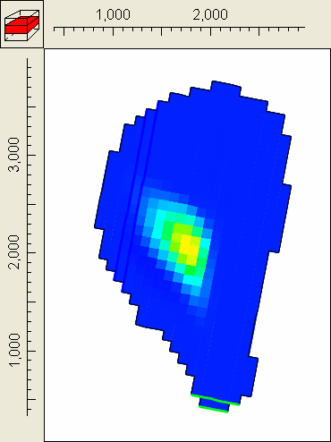

# Retardation (optional)

1. If the solute can be sorbed on the porous medium, its movement can be slowed down. This is known as retardation. Retardation is simulated with the Chemical Reactions package in MT3DMS. Select Model|MODFLOW Packages and Programs and check the check box for “RCT Chemical Reactions package”. Change the Sorption choice (ISOTHM) to Linear and click OK.
2. Three new data sets have been created, Bulk_Density, Sorption_Parameter1_tracer, and Sorption_Parameter2_tracer. Although the later is read by MT3DMS, it isn’t actually used when ISOTHM is set to linear so it can be ignored. Set the default formula for Bulk_Density to 1600000 and the default formula for Sorption_Parameter1_tracer to 1.154E-7.
3. Run MT3DMS again and compare the results with the previous results. (You do not need to run MODFLOW again.) When importing the model results, you will be prompted to either update the data sets with new values or create new data sets. Choose to create new data sets. Your results for time = 1000000000 should look similar to the figure on the right. The figure on the left shows the results without dispersion or retardation. The figure in the middle shows the results with dispersion but not retardation.

